Granting Access/Permissions to a People Profile

1) In Cayuse, click the “People” tab and search for your name:

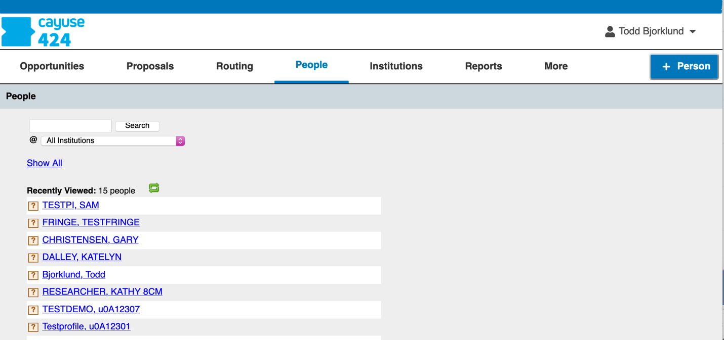

2) Click your name when the Search Results are displayed, and that opens your profile. Click the “Permissions” link on the right side of the page.

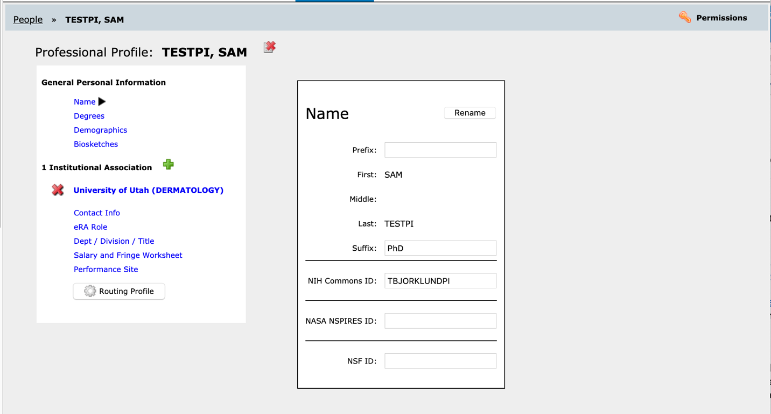

3) The following page will appear, showing the users that have permissions to your profile:
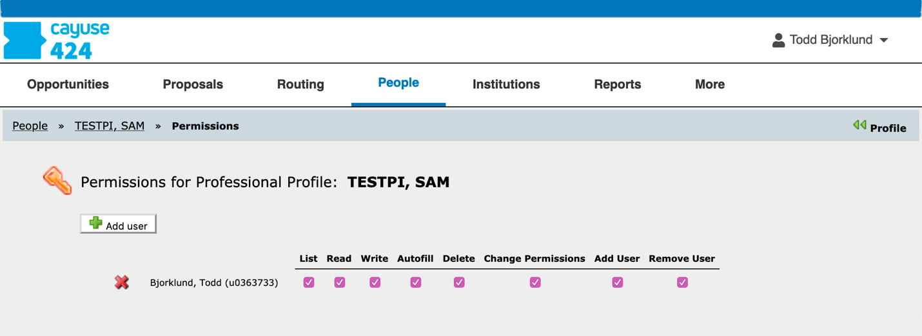

4) Click “Add user”, and the “Add Security Principal” dialog box appears. Search for the name of the person you want to add, and click it when it appears. It will then appear in the Permissions list:
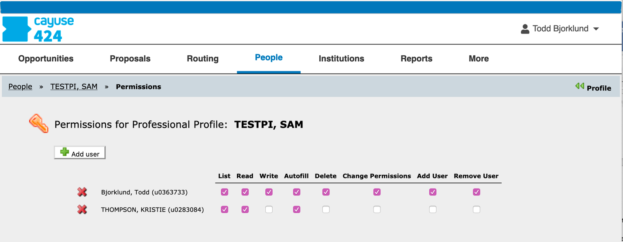

5) Click the “Write” check box to allow the delegate to edit your profile. Click “Change Permissions” and “Add User” to all the delegate to add new users to your profile.

Your changes will be saved when you navigate to another tab or sign out. Delegating permissions is permanent until revoked (by clicking the red X next to the person’s name).

